# UFCFTR-30-3

# Distribute & Enterprise Software Development

# Sprint Review Form

|  |  |
| --- | --- |
| Group: | 39 |
| Sprint: | 1 |
| Members: | Syed, Yasen, Benjamin Clorley, Aden |

<<Burn-down Chart>>

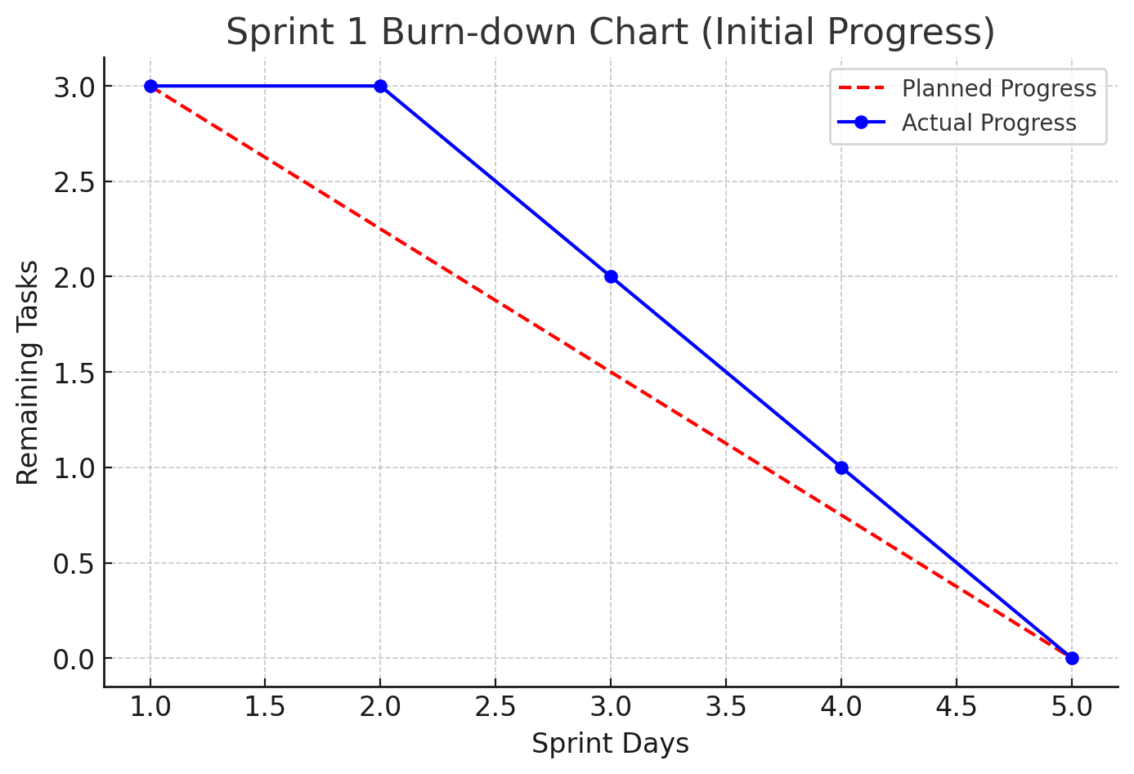

<<Backlog list>>

| **Task** | **Status** | **Assignee** |
| --- | --- | --- |
| Install Docker & Django | Done | All Members (Minus Ben E) |
| Set up Git repository | Done | Aden |
| Group meetup | Done | All Members( minus Ben E) |
| Initialize Django project | In Progress | Syed |
| Set up database | Not Started | Yasen |
| Configure Docker containerization | Not Started | Ben C |

<<Communication Issues>>

Benjamin Evans absent and not responding to emails.

Tutor has been notified.

<<Reflections>>

Sprint 1 focused on setting up **Docker, Django, and GitHub**, with collaboration from most members. However, **Benjamin Evans has not been responding to emails or meeting up**, and some tasks, like **Django initialization and database setup**, are still pending. Moving forward, we’ll prioritize **better communication and task completion** to stay on track.

<<Relevant Links>>

<https://github.com/Aden-Osman64/DaESD>